*EXPERIMENT 24: ONLINE STOCK MONITORING SYSTEM*

USE CASE DIAGRAM:

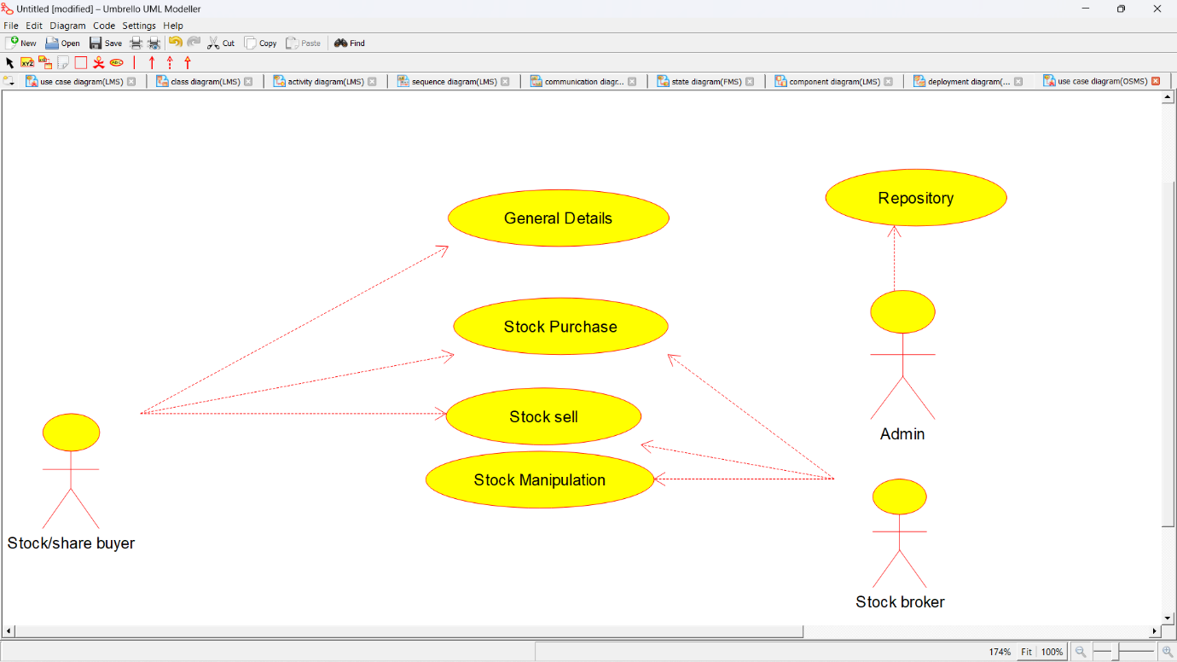

CLASS DIAGRAM: 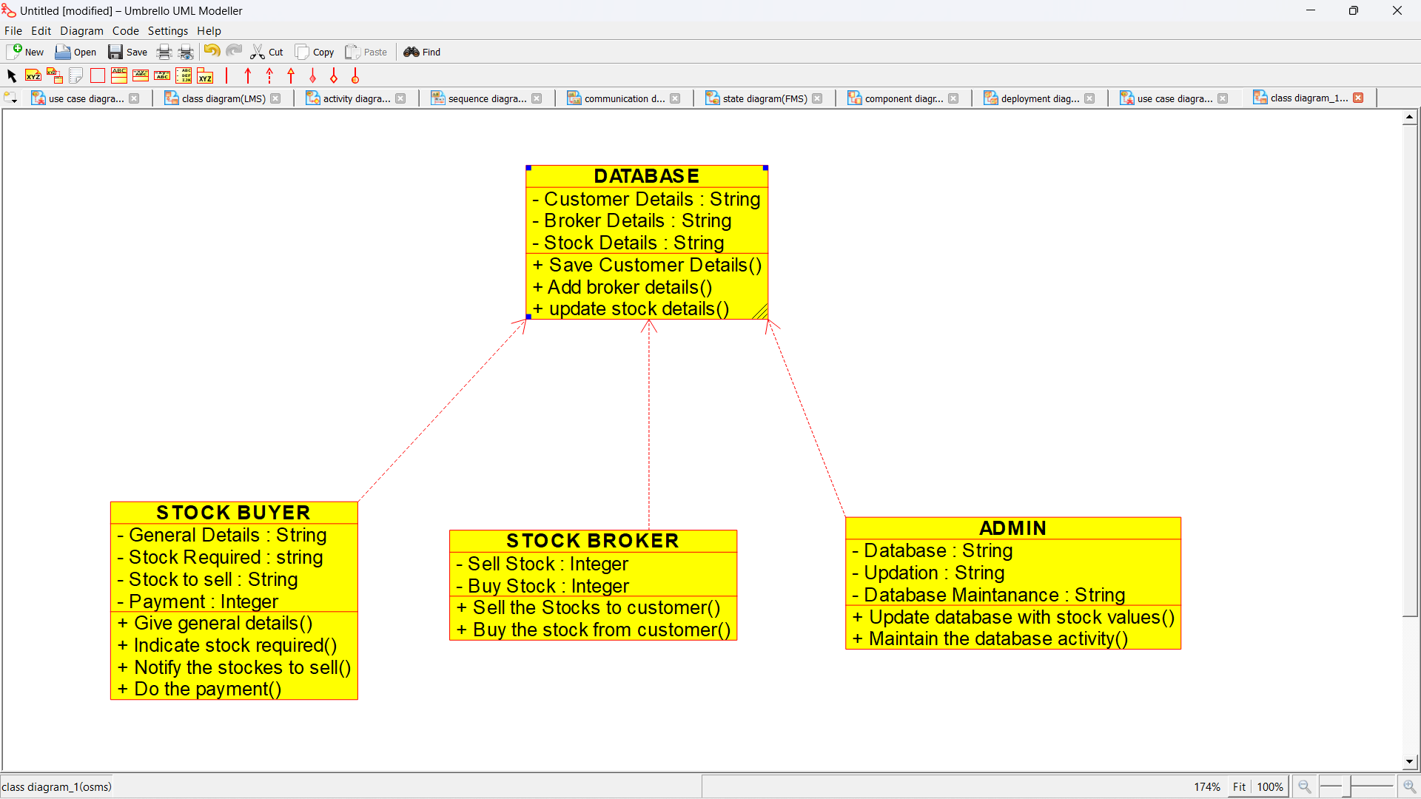

ACTIVITY DIAGRAM:

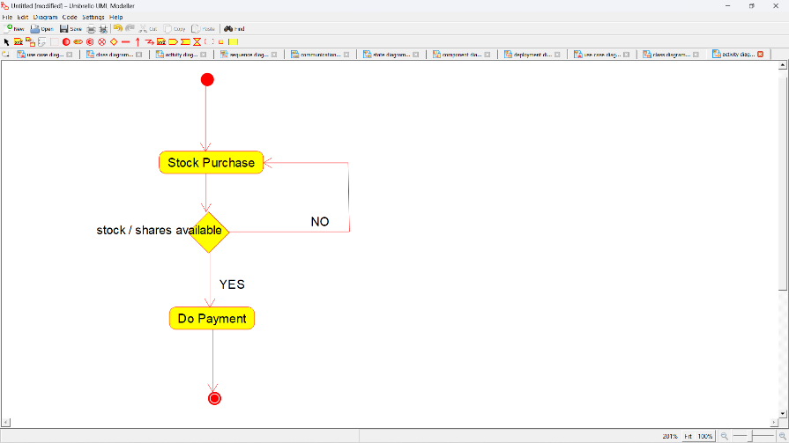

SEQUENCE DIAGRAM:

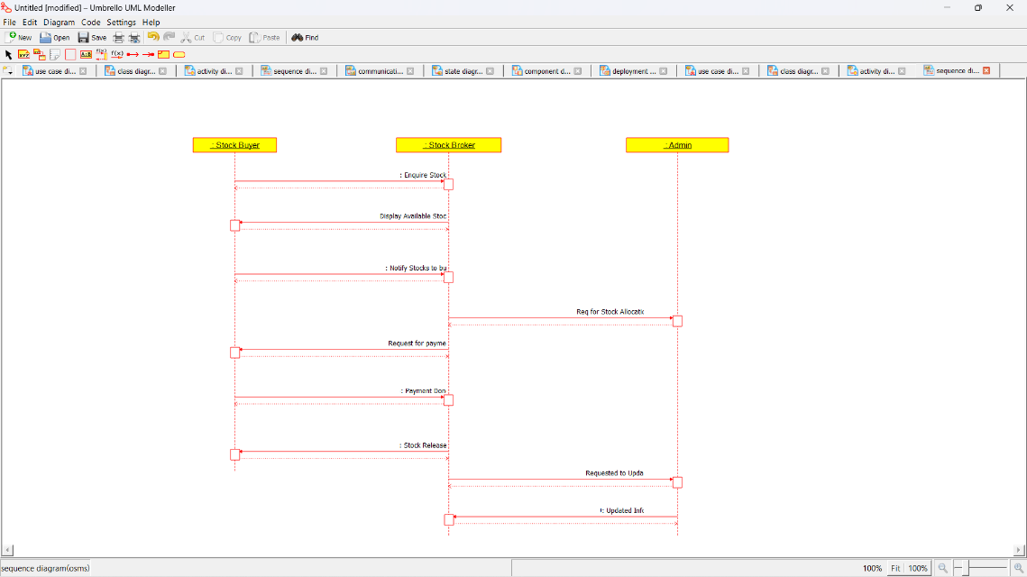

COLLABORATION DIAGRAM:

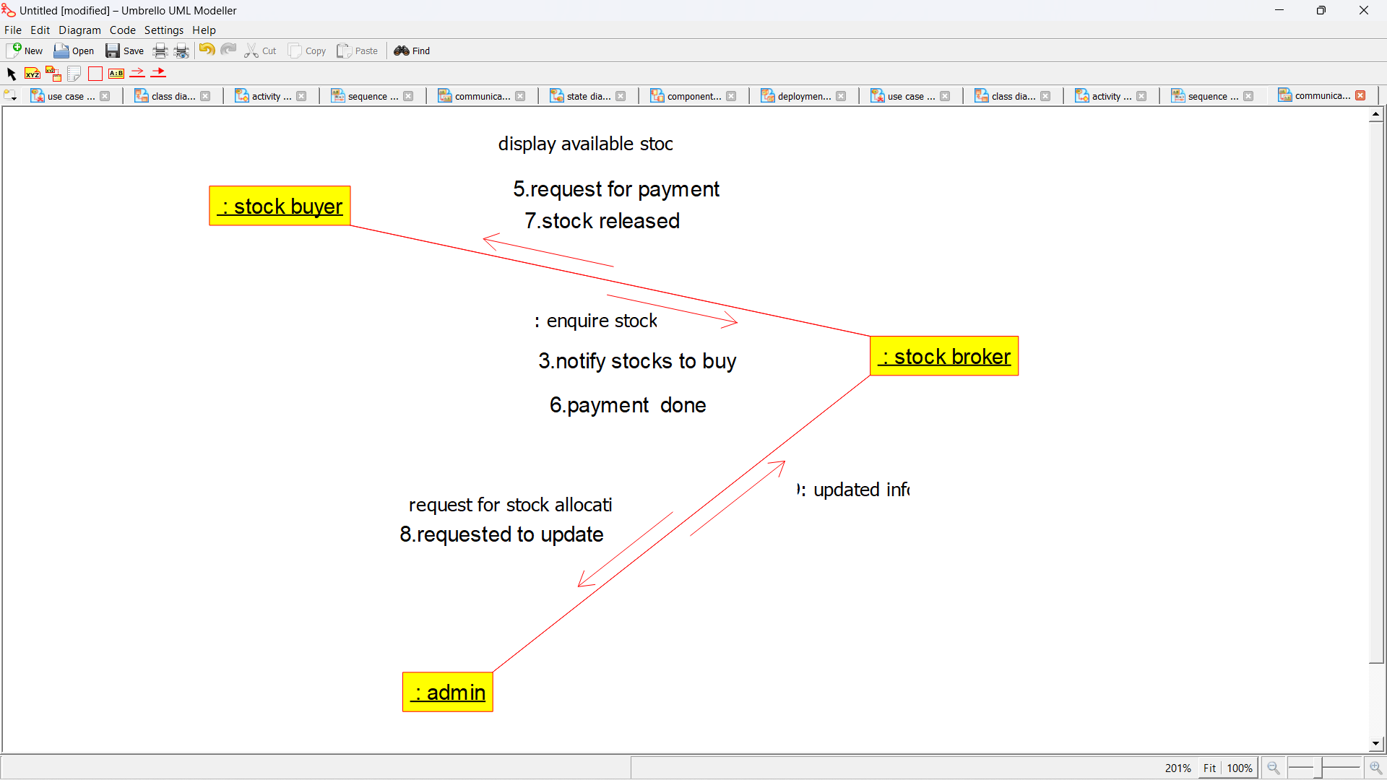

STATE CHART DIAGRAM:

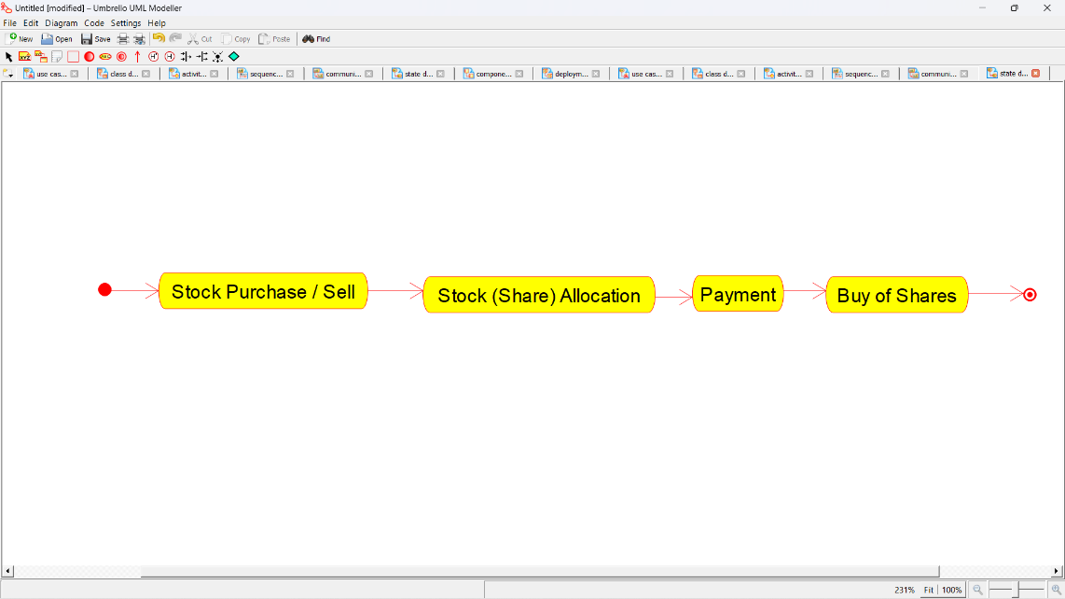

COMPONENT DIAGRAM:

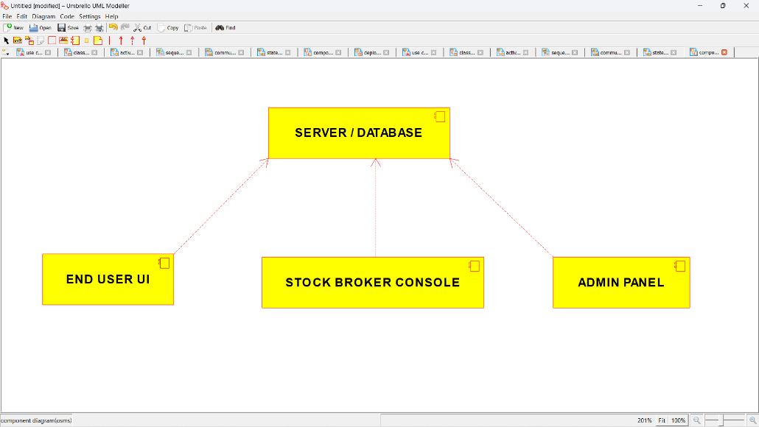

DEPLOYMENT DIAGRAM:

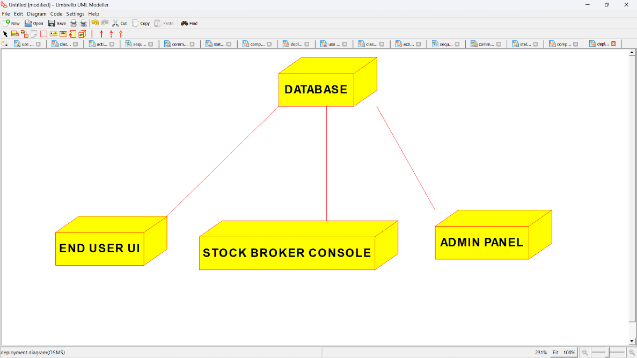

*PROGRAM CODING:*

/**

* Class ADMIN

*/

public class ADMIN {

//

// Fields

//

private String Database;

private String Updation;

private String Database_Maintanance;

//

// Constructors

//

public ADMIN () { };

//

// Methods

//

//

// Accessor methods

//

/**

* Set the value of Database

* @param newVar the new value of Database

*/

private void setDatabase (String newVar) {

Database = newVar;

}

/**

* Get the value of Database

* @return the value of Database

*/

private String getDatabase () {

return Database;

}

/**

* Set the value of Updation

* @param newVar the new value of Updation

*/

private void setUpdation (String newVar) {

Updation = newVar;

}

/**

* Get the value of Updation

* @return the value of Updation

*/

private String getUpdation () {

return Updation;

}

/**

* Set the value of Database_Maintanance

* @param newVar the new value of Database_Maintanance

*/

private void setDatabase_Maintanance (String newVar) {

Database_Maintanance = newVar;

}

/**

* Get the value of Database_Maintanance

* @return the value of Database_Maintanance

*/

private String getDatabase_Maintanance () {

return Database_Maintanance;

}

//

// Other methods

//

/**

*/

public void Update_database_with_stock_values()

{

}

/**

*/

public void Maintain_the_database_activity()

{

}

}

/**

* Class DATABASE

*/

public class DATABASE {

//

// Fields

//

private String Customer_Details;

private String Broker_Details;

private String Stock_Details;

//

// Constructors

//

public DATABASE () { };

//

// Methods

//

//

// Accessor methods

//

/**

* Set the value of Customer_Details

* @param newVar the new value of Customer_Details

*/

private void setCustomer_Details (String newVar) {

Customer_Details = newVar;

}

/**

* Get the value of Customer_Details

* @return the value of Customer_Details

*/

private String getCustomer_Details () {

return Customer_Details;

}

/**

* Set the value of Broker_Details

* @param newVar the new value of Broker_Details

*/

private void setBroker_Details (String newVar) {

Broker_Details = newVar;

}

/**

* Get the value of Broker_Details

* @return the value of Broker_Details

*/

private String getBroker_Details () {

return Broker_Details;

}

/**

* Set the value of Stock_Details

* @param newVar the new value of Stock_Details

*/

private void setStock_Details (String newVar) {

Stock_Details = newVar;

}

/**

* Get the value of Stock_Details

* @return the value of Stock_Details

*/

private String getStock_Details () {

return Stock_Details;

}

//

// Other methods

//

/**

*/

public void Save_Customer_Details()

{

}

/**

*/

public void Add_broker_details()

{

}

/**

*/

public void update_stock_details()

{

}

}

/**

* Class STOCK_BROKER

*/

public class STOCK_BROKER {

//

// Fields

//

private Integer Sell_Stock;

private Integer Buy_Stock;

//

// Constructors

//

public STOCK_BROKER () { };

//

// Methods

//

//

// Accessor methods

//

/**

* Set the value of Sell_Stock

* @param newVar the new value of Sell_Stock

*/

private void setSell_Stock (Integer newVar) {

Sell_Stock = newVar;

}

/**

* Get the value of Sell_Stock

* @return the value of Sell_Stock

*/

private Integer getSell_Stock () {

return Sell_Stock;

}

/**

* Set the value of Buy_Stock

* @param newVar the new value of Buy_Stock

*/

private void setBuy_Stock (Integer newVar) {

Buy_Stock = newVar;

}

/**

* Get the value of Buy_Stock

* @return the value of Buy_Stock

*/

private Integer getBuy_Stock () {

return Buy_Stock;

}

//

// Other methods

//

/**

*/

public void Sell_the_Stocks_to_customer()

{

}

/**

*/

public void Buy_the_stock_from_customer()

{

}

}

/**

* Class STOCK_BUYER

*/

public class STOCK_BUYER {

//

// Fields

//

private String General_Details;

private String Stock_Required;

private String Stock_to_sell;

private Integer Payment;

//

// Constructors

//

public STOCK_BUYER () { };

//

// Methods

//

//

// Accessor methods

//

/**

* Set the value of General_Details

* @param newVar the new value of General_Details

*/

private void setGeneral_Details (String newVar) {

General_Details = newVar;

}

/**

* Get the value of General_Details

* @return the value of General_Details

*/

private String getGeneral_Details () {

return General_Details;

}

/**

* Set the value of Stock_Required

* @param newVar the new value of Stock_Required

*/

private void setStock_Required (String newVar) {

Stock_Required = newVar;

}

/**

* Get the value of Stock_Required

* @return the value of Stock_Required

*/

private String getStock_Required () {

return Stock_Required;

}

/**

* Set the value of Stock_to_sell

* @param newVar the new value of Stock_to_sell

*/

private void setStock_to_sell (String newVar) {

Stock_to_sell = newVar;

}

/**

* Get the value of Stock_to_sell

* @return the value of Stock_to_sell

*/

private String getStock_to_sell () {

return Stock_to_sell;

}

/**

* Set the value of Payment

* @param newVar the new value of Payment

*/

private void setPayment (Integer newVar) {

Payment = newVar;

}

/**

* Get the value of Payment

* @return the value of Payment

*/

private Integer getPayment () {

return Payment;

}

//

// Other methods

//

/**

*/

public void Give_general_details()

{

}

/**

*/

public void Indicate_stock_required()

{

}

/**

*/

public void Notify_the_stockes_to_sell()

{

}

/**

*/

public void Do_the_payment()

{

}

}